Post Request Screenshots

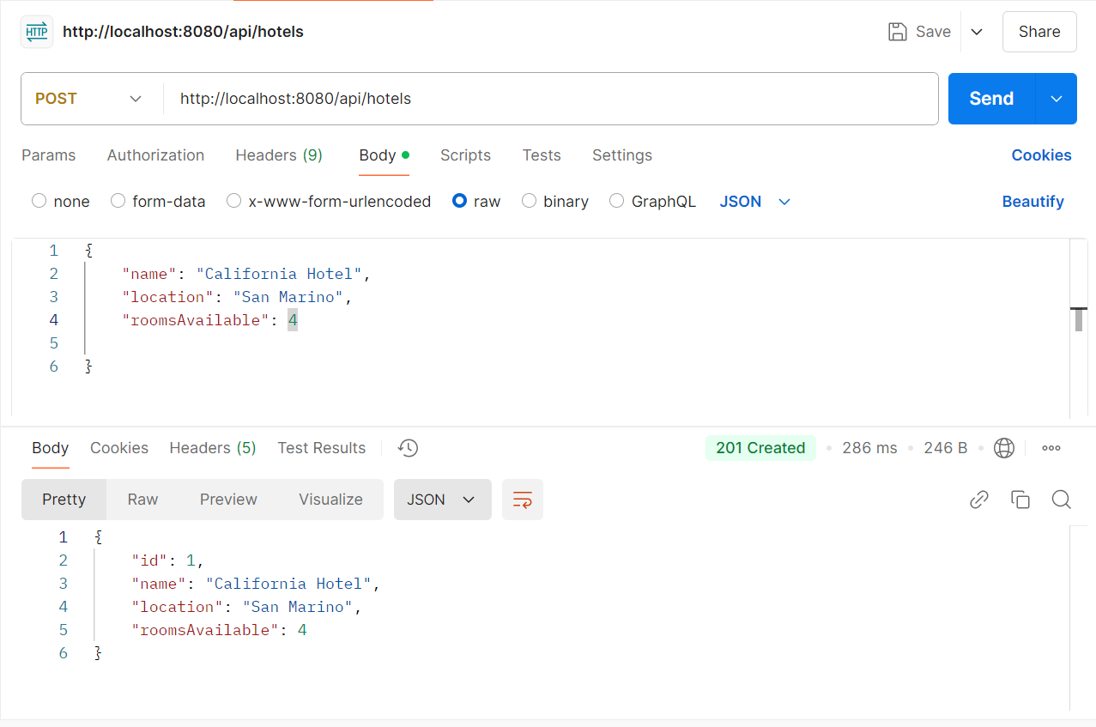

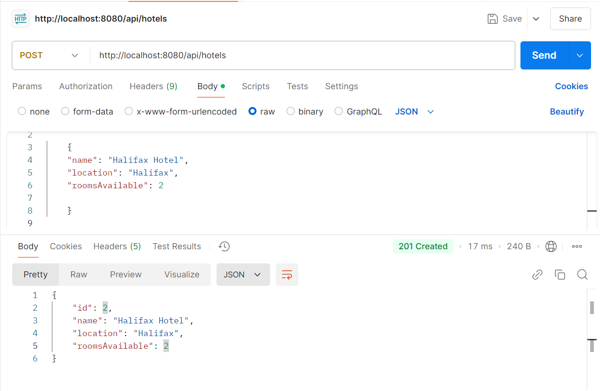

Get Request Screenshots

